Digital Dice

Description:
The Digital Dice is an electronic project that simulates the working of a traditional dice using an ESP32 microcontroller. When the push button is pressed, the ESP32 generates a random number between 1 and 6 and displays it on the OLED display. This project demonstrates the use of random number generation, input buttons, and OLED display interfacing with ESP32.
Block Diagram:
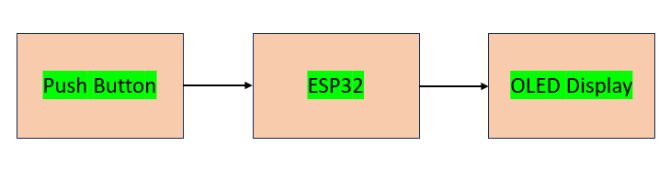
Pinout / Circuit Connection:
- Push Button: One terminal of the push button is connected to GPIO 4 of ESP32, and the other terminal is connected to GND.
- OLED Display: The VCC pin of the OLED is connected to 3.3V of ESP32, the GND pin is connected to GND, the SDA pin is connected to GPIO 21, and the SCL pin is connected to GPIO 22.
Components Required:
- ESP32 Development Board
- Push Button
- OLED Display (SSD1306)
- Jumper wires
- Breadboard
Working Principle:
The push button acts as an input device. When the button is pressed, the ESP32 generates a random number between 1 and 6 using its random number function. The generated number is then sent to the OLED display using the I2C communication protocol, and the number appears on the screen like the result of a dice roll.
Operation (Step-by-Step):
- Power ON the ESP32 board.
- The OLED display initializes and waits for input.
- When the push button is pressed, ESP32 generates a random number between 1 and 6.
- The generated number is displayed on the OLED screen.
- Each time the button is pressed, a new number appears, simulating a dice roll.
Arduino Code:
#include <Wire.h>
#include <Adafruit_GFX.h>
#include <Adafruit_SSD1306.h>

#define SCREEN_WIDTH 128
#define SCREEN_HEIGHT 64

Adafruit_SSD1306 display(SCREEN_WIDTH, SCREEN_HEIGHT, &Wire, -1);

#define buttonPin 4

void setup() {
pinMode(buttonPin, INPUT_PULLUP);
Serial.begin(115200);

if(!display.begin(SSD1306_SWITCHCAPVCC, 0x3C)) {
Serial.println("OLED not found");
while(true);
}

display.clearDisplay();
display.setTextSize(2);
display.setTextColor(WHITE);
display.setCursor(10,20);
display.println("Dice");
display.display();
}

void loop() {

if(digitalRead(buttonPin) == LOW) {

int diceValue = random(1,7);

display.clearDisplay();
display.setTextSize(3);
display.setCursor(40,20);
display.println(diceValue);
display.display();

delay(500);
}
}
Conclusion:
The Digital Dice project provides a simple and interactive way to simulate a dice using electronics. It demonstrates the integration of ESP32, push button input, and OLED display output, making it a useful example for learning basic embedded system programming.
References:
[1] Arduino Project Hub, “Interfacing OLED Display with ESP32,” Arduino Project Hub. [Online]. Available: https://projecthub.arduino.cc
[2] Espressif Systems, “ESP32 Technical Reference Manual,” Espressif Systems, 2023. [Online]. Available: https://www.espressif.com

